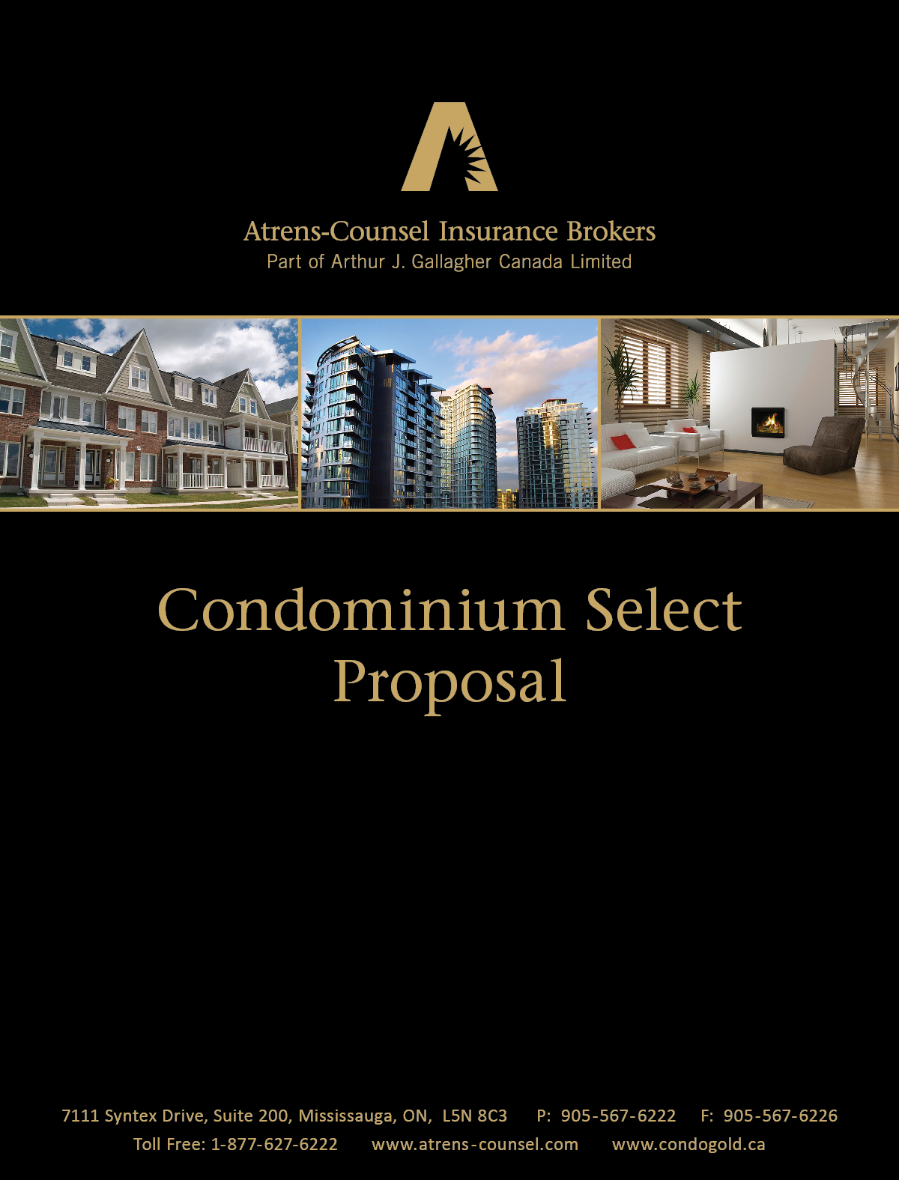

**Condominium Select – Proposal**

*Prepared for:*

**Ottawa Carleton Standard Condominium Corporation No. 1004  
10 Rosemount Avenue  
Ottawa, ON K1Y 4G9**

*Managed By:*

**Taggart Realty Management**

*Effective:*

**October 25, 2017 to October 25, 2018**

*Presented By:*

**Atrens-Counsel Insurance Brokers**

**Part of Arthur J Gallagher Canada Limited**

*Prepared By:*

*Lisa Cieplucha, RIB (On) CAIB*

Senior Account Manager - Condominium Specialist

On September-14-2017

**Please be advised that the following quotation is subject to no claims in 5 years. Failure to disclose any claims will result in this policy being voided.**

DISCLAIMER - The abbreviated outlines of coverage used throughout this proposal are not intended to express any legal opinion as to the nature of coverage. They are only visuals to a basic understanding of coverage. Please read your policy for specific details of coverage.

**Dear Board of Directors**

We are pleased to provide for you and the Unit Owners you represent, our quotation for *the* ***Atrens-Counsel Condominium Select*** program.

For over 30 years, Atrens-Counsel has provided insurance expertise to the condominium community in the province of Ontario. The ***Atrens-Counsel Condominium Select*** program offers a comprehensive manuscript policy that incorporates many additional extensions and features that are vital to minimize disruption and adverse financial impact in the event of a loss. This program is supported by an experienced condo team who are available to help Board members and Property Managers with insurance related decisions that may have a direct impact on their communities while understanding the nuances of condominium living.

While premium costs are always a key consideration, our primary focus is to manage the Corporation’s Insurance responsibilities by offering an exclusive insurance program with markets that have a reputation for fair and prompt claims settlement.

We look forward to the opportunity to manage the long term insurance needs of your Corporation. We are confident that the ***Atrens-Counsel Condominium Select*** policy will provide you the peace of mind currently experienced by over 3000 Condominium Corporations in the province of Ontario.

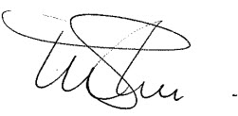Yours very truly,



Wm. Mark Shedden, FCIP Tom Gallinger, FCIP

President Vice President

**Ottawa Carleton Standard Condominium Corporation No. 1004**

**Underwritten by:** Economical Mutual Insurance Company

**COVERAGE SUMMARY**

**PROPERTY OF EVERY DESCRIPTION**

**CAUTION: Current policy wording includes a Co-Insurance clause**

**Limit of Insurance** …………………………………..........… **$ 19,049,625**

**Deductibles**

Standard ………………………………..…................. $ 5,000

Water ……………………………………………………….. $ 5,000

Sewer Backup …………………………………………... $ 5,000

Flood ………………………………………………………. $ 10,000 **currently $25,000**

Earthquake ……………………………….... 3% or $ 150,000

**COMPREHENSIVE GENERAL LIABILITY**

**Limit of Insurance** ……………………………..............…… $ 5,000,000 **see recommendations**

**Deductibles**

Property Damage ………………………...........…… $ 1,000

Bodily Injury ………………………………...........…… $ 1,000

**Excess Liability Limit of Insurance** ………….........…… $ 5,000,000

**COMMERCIAL BLANKET BOND**

**Limit of Insurance** …………………………………..............…… $ 50,000

Third Party endorsement included

**HUMAN RIGHTS DEFENCE COSTS**

**Limit of Insurance** ……………………………..............……… $ 100,000

**Aggregate Limit** ……………………………...............………… $ 200,000

**DIRECTORS & OFFICERS LIABILITY**

**Limit of Insurance** ………………………………….......…..... $ 5,000,000 **see recommendations**

With NO failure to place insurance exclusion

**LEGAL EXPENSE INSURANCE New – see recommendations**

**Limit of Insurance**…………………………………………………….$ 25,000 **currently not included**

**Aggregate Limit**……………………………………………………… $ 125,000

**Employment Disputes Extension**................................. Optional

**ELECTRICAL & MECHANICAL EQUIPMENT BREAKDOWN COVERAGE - BOILER & MACHINERY**

**Limit of Insurance** ……………………………………........... $ 19,049,625

Extra Expense ……………………………………………….......... $ 250,000

**Deductibles**

Standard ……………………………………………..........$ 2,500

Air Conditioning………………….………………………$ 2,500

**ADDITIONAL COVERAGE EXTENSIONS** …………………..… See attached

**Ottawa Carleton Standard Condominium Corporation No. 1004**

Our Condominium Select **quotation** based on the values outlined in the Coverage Summary is presented with an annual premiumof **$12,053** plus 8% sales tax.

**RECOMMENDATIONS**

* To increase the limit of **Comprehensive General Liability** to **$15,000,000** itwould cost an additional **$500** plus 8% tax annually.
* To increase the limit of **Directors and Officers Liability** to **$10,000,000** it would cost an additional **$450** plus 8% tax annually. This limit may be increased only if the Comprehensive General Liability coverage carried reflects the same limit or higher.
* **Commercial Blanket Bond (Fidelity) coverage** (**Benefit**: Protects the funds of the Corporation from theft by Board members or Property Management. It is very important that the Corporation carry an adequate Fidelity Bond limit). Please call our office to discuss whether additional protection is required by your Corporation.
* Does your Corporation employ concierge, superintendant or other employees within your condo? If so, we strongly recommend enhancing your Legal Expense Insurance to provide coverage for Employment Disputes. To add the **Employment Disputes** enhancement onto your **Legal Expense Insurance** it will cost an additional premium of **$75** plus 8% tax annually.

**PROPERTY COVERAGE EXTENSIONS**

Your Manuscript policy is subject to the following extensions of coverage; please be reminded for complete coverage details please refer to your policy wording or contact Atrens-Counsel Insurance Brokers.

* Blanket Amount on Building and Contents;
* No-Coinsurance Clause;
* Replacement Cost (No depreciation applied at time of loss);
* Same site provision deleted;
* Coverage Away from Premises $150,000

(Building and Contents while off premises for repair or storage)

* Extra Expense $250,000

(This coverage will pay the additional expenses over and above the Corporation’s usual cost of conducting operations in the event of loss or damage to the insured property.)

* Increase in Cost of Repair

(This basic policy states that settlement shall be based on the cost of repairing, replacing, etc. with materials of like kind and quality. However, with building standards being improved every year, it is possible that replacement or reinstatement with materials of like kind and quality is restricted or prohibited by a law, by-law, or ordinance. In the event of a loss, should a law, by-law or ordinance prohibit the replacement of the building with materials of like kind and quality, this extension will pick up the additional cost.)

* Radio and Television Towers Covered;
* Master Key Coverage in the amount of $25,000;
* Debris Removal included;
* Property of Others $2,500 per Person / $50,000 per occurrence;

(Provided that the Condominium Corporation is responsible for such property the extension also includes coverage for the Property of Unit Owners provided that the Condominium Corporation has accepted such property for custody and safekeeping and is legally liable.)

* Landscaping $100,000 per Occurrence and $1,000 per one tree, shrub, etc;

(Coverage for Landscaping caused by a Named Peril – e.g. Fire, Lightning, Explosion, Riot, Impact by Aircraft or Vehicles not owned by the insured or any of their employees.)

Continued on the next page

**PROPERTY COVERAGE EXTENSIONS continued**

* Valuable Papers $75,000

Under a Fire Policy, valuable papers are covered only for the cost of material and not labour involved in transcribing the records; it does not contemplate the cost of research, surveys and other expenditures incurred in developing sufficient information to enable reproduction. The valuable papers cover insures such additional expenditures as may be necessary for reproducing the records.)

* Broad Form Money and securities $5,000 including In and Out robbery
* Sixty Day Cancellation Clause;
* Trustee Fees $50,000

(This coverage will pay the fees and disbursements of the insurance trustee who is responsible for collection and disbursing the insurance funds in compliance with the Condominium Act of Ontario.)

* Glass – including coverage for Vandalism and Malicious Mischief and Accidental Breakage;
* Insurer waives the right to repair, replace or re-build should the owners vote not to repair, and terminate the government of the property, in compliance with the Condominium Act;
* Standard Unit By-Law Recognition

(Policy automatically covers property as defined by any standard unit by-law passed in compliance with the Condominium Act of Ontario);

* Waiver of Subrogation against the Condominium Corporation, its Directors, Officers and individual Unit Owners, its Managers, Agents and Employees, and Insurance Trustee;
* Professional Fees $50,000 to certify or produce information to substantiate loss;
* On Premises Pollution Cleanup $10,000

**LIABILITY COVERAGE EXTENSIONS**

This coverage is written on a Comprehensive General Liability form and provides coverage against the legal liability imposed by law, as the result of Bodily Injury or Property Damage, arising out of the Corporation’s activities as a Condominium. – Subject to the usual exclusions and limitations.

This policy is extended to provide coverage on behalf of the individual Unit Owners in respect to their interest in the common elements of the Condominium.

In order to ensure that the Condominium Corporation’s legal liability is fully and properly covered, the following extensions have been included in the policy:

* The Property Damage coverage is changed from an “Accident” basis to the broader “Occurrence” basis. The bodily injury coverage is already on an “Occurrence” basis;
* Contingent Employer’s Liability coverage – on an “if any” basis;
* Personal Injury Insurance with employees exclusion deleted;
* Independent Contractors – on an “if any” basis;
* Sixty Day Cancellation Clause;
* Broad Form Contractual – on an “if any” basis. The basic policy excludes coverage for liability assumed by an insured under any written agreements – other than “Incidental Contracts.” This extension picks up this additional exposure;
* Non-Owned Automobile Coverage – This extension provides coverage against liability imposed by law against the Condominium Corporation for loss or damage arising from the use or operation of any automobile not owned in whole or in part by or licensed in the name of the Insured. – i.e. any member of the Condominium Corporation using their own vehicles on behalf of the Condominium Corporation;
* Contractual Liability for Non-Owned Automobiles;
* Cross Liability Clause (As there is no coverage provided normally under most policies for a suit brought by one insured against another – i.e., Unit Owner versus the Condominium Corporation – this clause is vital in order to protect the Condominium Corporation against such a possibility;
* Employee as Additional Insured’s;
* Medical Payments $2,500 each person / $25,000 each accident
* Products and Completed Operations;
* Tenant’s Legal Liability $250,000 blanket each location
* Employee Benefit Coverage $100,000 per person / $300,000 per Occurrence
* Employers Liability
* Personal Injury Intentionally Caused amendment;
* Limited Third Party Pollution Liability

**VALUE ADDED PROGRAMS AVAILABLE**

As a Condominium Corporation insured with Atrens-Counsel Insurance Brokers please review the following **value added programs** available to both Residential and Commercial Condominiums. These programs are designed to provide the utmost protection for a reduced price allowing your Condominium community to enjoy truly carefree condo living.

***condoBiz Plus***

***…for businesses in commercial condos***

A policy that meets the unique needs of businesses that operate out of commercial condos, from garages to retail stores to manufacturing and distribution.

***Condo Gold***

***...for unit owners***

Insurance specifically designed to work hand-in-hand with your corporation’s policy. [www.condogold.ca](http://www.condogold.ca)

 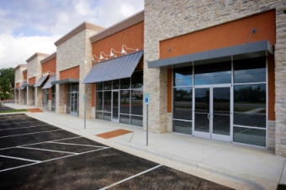

***applianceProtector***

***…for unit owners***

Easy living knowing your major appliances are protected, all components and parts that affect the operation, no age restriction, $50 deductible and no pre-inspections required. Affordable annual premiums and easy to get started, just call 1-866-615-0681 and learn more.

***providerProtector***

***…for community services***

A program that provides affordable liability coverage for service providers who operate specifically in your condominium, for example handy-persons, yoga instructors, special event planners, garden club organizers, and many more.

 

** **

***rentalProtector***

***…for unit landlords***

Protect your rented investment properties from water damage, fire and the loss of rental value. This affordable policy can be written as a stand-alone policy.

***eventProtector***

***…for special functions***

Do your unit owners hold events or social functions in your party room or common facilities? Liability coverage covers events including host liquor liability.

**Atrens-Counsel Insurance Brokers is a full service Brokerage providing all lines of Insurance products;**

Homeowners Insurance

Personal Automobile Insurance

High Valued Homes

Hard to Place Homes

Seasonal Homes

Tenants Insurance

Marine Coverage

Commercial Business Insurance – Manufactures, Contractors, Wholesalers, Offices and Retails Stores

Commercial Automobile Insurance – Individually owned units, Garage and Fleets

Commercial General Liability Protection

Atrens-Counsel Insurance Brokers will manage your Insurance coverage so you can have peace of mind knowing your investments are protected.

**Should you have any questions regarding this quotation or any of the extended features, please do not hesitate to contact our office.**